Dataset B: Air Travel Delay

Step 1. Problem Definition

1.1 Business Problem
One of most expensive and disruptive issues in commercial aviation is flight delays. Every year, aircraft delays cost the US airline industry billions of dollars due to higher fuel consumption, personnel overtime, gate disputes and passenger compensation. The following regression problem is defined by this analysis:

“Can we predict the arrival delay (in minutes) of a commercial flight, given information available at or before the time of departure?”

The goal variable in this regression problem is ArrDelay or the amount of time a flight is delayed in relation to its scheduled arrival time. Early arrivals are indicated by negative values. Predictive features that are known at or soon after departure include departure delay, scheduled departure time, carrier, origin and destination airports, day of the week, distance and taxi-out time.

1.2 Why Regression?
Although it is easier, a binary classification method (delayed vs. not delayed) ignores important information. Despite the operational differences between a flight that arrives 6 minutes late and one that arrives 4 hours late, a classifier treats them the same. The algorithm generates granular, actionable outputs that are directly helpful for operational decision making by forecasting the precise delay in minutes.

1.3 Stakeholders and Benefits
Stakeholder | Benefit from Solving the Problem
Airlines (Southwest, ExpressJet) | Proactively manage crew scheduling, gate reassignments and fuel planning when a delay is predicted. Reduces cascading delays across the network.
Airport Operations Teams | Allocate ground crew, gates and baggage handling resources more efficiently based on predicted arrival times.
Passengers | Receive earlier and more accurate delay notification, allowing them to rebook connections and adjust plans.
Air Traffic Control | Anticipate congestion at destination airports and adjust sequencing and holding patterns proactively.
Travel Booking Platforms | Surface real-time delay risk estimates to users at the time of booking or check-in, improving customer experience.

Step 2. Data Description

2.1 Dataset Overview
Each row in the dataset represented a single commercial flight between two US airports in January 2008. The 29 attributes covered five broad categories: temporal information (date and scheduled times), airlines information (carrier and flight identifiers), route information (origin and destination airports), delay information (departure and arrival delays), operational data (distance, cancellations, taxi times).
Property | Value
Total Rows (instances) | 101,000
Total Columns (attributes) | 29
Missing Values | Present (dropped during cleaning)
Duplicate Rows | Present (removed during cleaning)

2.2 Data Types of Each Attribute

The 29 attributes were inspected for their stored data type. Fourteen columns were correctly stored as numeric types (int64 and float64). 10 columns that represented numerical values such as time and distance were incorrectly stored as string (object) types. The remaining 5 columns are legitimate categorical attributes.
Attribute | Data Type | Description
ArrDelay | float64 | Arrival delay in minutes
DepDelay | float64 | Departure delay in minutes
UniqueCarrier | str | Airline carrier code
Origin and Dest | str | Origin and Destination airport code
DayOfWeek | Int64 | Day of the week (1=Mon to 7=Sun)
Distance, Cancelled, Diverted | Str (Should be numeric) | Flight distance in miles, whether flight was cancelled (0/1), was diverted (0/1)
DepTime and ArrTime | Str (Should be numeric) | Actual departure and arrival time (HHMM format)
CRSDepTime | Str (Should be numeric) | Scheduled departure time (HHMM format)
Year, Month, DayofMonth, FlightNum | Int64 | Which year, specific month, day of the month, each flight’s number
TaxiIn, TaxiOut, CarrierDelay, WeatherDelay, NASDelay, SecurityDelay, LateAircraftDelay | Float 64 | Taxing time, carrier and weather delays, security delays etc.
TailNum, CancellationCode | str | Flight cancellation code, flight license number
ActualElapsedTime, CRSElapsedTime, CRSArrTime, AirTime | Str (Should be numeric) | Elapsed time, flight air time etc.

2.3 Missing Values and Duplicates
Missing values were identified across 15 of the 29 columns. The remaining 14 columns were complete with no missing values. The table below summarises the missing value count and percentage for all affected columns:
Column | Missing Count | Missing Percentage
CancellationCode | 99,364 | 98.38%
CarrierDelay, WeatherDelay, NASDelay, SecurityDelay, LateAircraftDelay | 81,177 | 80.37%
TailNum | 4,146 | 4.11%
ArrDelay | 3,300 | 3.27%
DepDelay | 3,150 | 3.12%
ArrTime | 1,281 | 1.27%
DepTime | 1,127 | 1.12%
TaxiIn | 2,311 | 2.29%
TaxiOut | 2,153 | 2.13%
ActualElapsedTime, AirTime | 1,310 | 1.30%

The high missing values in CancellationCode and the five delay cause columns is not a data error but a natural property of the dataset as these fields are only recorded when cancellation or delay actually occurs. All the missing values are addressed appropriately in the data cleaning step.

2.4 Unique Values in Categorical Features
Fifteen columns were identified as categorical which were further classified by the concept of cardinality (the number of unique values they contain). The low cardinality columns (15 or fewer unique values, the number 15 was chosen at random as a lot of values were observed to be below it) were inspected in detail as they seemed most relevant for modelling and revealed several data issues and which were later resolved in data cleaning step.
Column | Unique | Missing Actual Values / Notes
CancellationCode | 3 | A (Carrier), B (Weather), C (NAS) - Clean
Cancelled | 6 | '0', '1', 'TRUE', 'FALSE', 'Y', 'N' - Mixed encoding, needs fixing
Diverted | 6 | '0', '1', 'TRUE', 'FALSE', 'Y', 'N' - Mixed encoding, needs fixing
UniqueCarrier | 10 | 'WN', 'wn', ' WN', 'WN ', 'XE', 'xe', ' XE', 'XE ', 'W', 'X' - Mixed case and spaces, needs fixing
Origin | 308 | High cardinality - 308 unique airport codes
Dest | 312 | High cardinality - 312 unique airport codes

2.5 Unique Values in Categorical Features

Descriptive statistics were computed for all 14 columns to understand their central tendency, spread and range.
Column | Mean | Median | Std Dev | Min | Max | Note
ArrDelay | 5.71 | -2.0 | 30.91 | -57 | 500 | Target variable
DepDelay | 10.37 | 1.0 | 28.34 | -44 | 516 | Key predictor
Distance | 627.7 | 451.0 | 441.7 | -2176 | 2363 | Has negatives
TaxiOut | 10.93 | 9.0 | 5.99 | 1 | 150 | Clean
TaxiIn | 4.77 | 4.0 | 2.98 | 1 | 213 | Clean
AirTime | -- | -- | -- | -- | -- | Has negatives

The negative values in ArrDelay and DepDelay represent early arrivals and departures which are valid and expected. However, negative value in Distance and AirTime are Physically impossible and probably represent a data recording error, which are further addressed in the cleaning step.

Step 3. Data Cleaning and Processing

Data cleaning is the process of detecting and correcting errors, inconsistencies and inaccuracies in the dataset to ensure it is accurate, consistent and ready for modelling. The following data quality issues were identified in step 2 and addressed in this step.

3.1 Fixing Incorrect Data Types
Ten columns were identified as being stored in incorrect data types, the numerical values were stored as strings. These columns included time columns (DepTime, CRSDepTime, ArrTime, CRSArrTime), duration columns (ActualElapsedTime, CRSElapsedTime, AirTime), Distance, Diverted and Cancelled. If kept as strings they were hindering the mathematical operations, statistical analysis and could have caused issues with the modelling. All these columns were converted to numeric using a coerce strategy in which any value that could not be converted was replaced with NaN rather than causing an error, ensuring the conversion was safe and handled any hidden dirty values automatically.
Column | Type Before | Type After Conversion
DepTime | str | float64
CRSDepTime | str | float64
ArrTime | str | float64
CRSArrTime | str | float64
ActualElapsedTime | str | float64
CRSElapsedTime | str | float64
AirTime | str | float64
Distance | str | float64
Cancelled | str | float64
Diverted | str | float64

3.2 Standardising Inconsistent Values
Going further three columns contained inconsistent value encoding, they basically had different representations of the same categories, which could have caused them to be treated as multiple different categories by a model, leading to incorrect analysis and poor performance.

For the Cancelled and Diverted Columns, we already converted their values to numeric (0.0/1.0), now we simply filled the NaN values with 0 to simply and converted them to int data type, hence making them clean integers (0/1).
While for UniqueCarrier we first removed whitespaces and made everything capitalized then the mapping of partial and corrupted code to correct carrier code was done, the table below gives the summary of what changes were done.
Column | Issue | Fix Applied | Before | After
Cancelled | Mixed encoding: 0/1/TRUE/FALSE/Y/N | Filled NaN with 0, converted to integer | 3 | 2
Diverted | Mixed encoding: 0/1/TRUE/FALSE/Y/N | Filled NaN with 0, converted to integer | 3 | 2
UniqueCarrier | Mixed case, spaces, partial codes (W, X) | Stripped spaces, uppercased, mapped W->WN and X->XE | 10 | 2

3.3 Handling Invalid Entries

Four columns were found to contain physically impossible negative values being, Distance, ActualElapsedTime, CRSElapsedTime and AirTime.a flight cannot have a negative distance value, elapsed or air time. These clearly seemed like data recording errors.

For strategy, all rows containing a negative value in any of these four columns were removed. It only accounted for around 1% of the dataset. A total of 1009 rows were removed, the table below shows how much each column had.
Column | Negative Count | Percentage
Distance | 248 | 0.25%
ActualElapsedTime | 234 | 0.23%
CRSElapsedTime | 273 | 0.27%
AirTime | 256 | 0.25%

3.4 Handling Missing Values

After the previous cleaning steps, 19 columns still had missing values. After a bit self-analysis three strategies were applied based on the nature and meaning of each column.

Strategy 1 - Dropping Columns Entirely

Two columns were dropped entirely, CancellationCode had around 98% missing values and only populated data of cancelled flights, making is useless for predating arrival delay, TailNum is the aircraft registration number with has no predictive value for delay.

Strategy 2 – Filling with 0

The five delay columns were filled with 0, as these columns are only recorded when a delay actually occurs, a missing value basically means the flight had 0 delay from that cause, so filling them with 0.

Strategy 3a – Dropping some rows

Rows where ArrDelay values were missing were dropped as it is the target variable and cannot be estimated or filled. Rows where ArrTime or DepTime were missing were also dropped, as these missing values indicated cancelled or diverted flights whose records are unreliable for modelling.

Strategy 3b – Filling with median

Nine remaining columns with small proportions of missing values were filled with their respective median values. Median was preferred over mean as it is robust to the outliers known to exist in delay and time columns. The columns filled were: DepDelay, TaxiIn, TaxiOut, ActualElapsedTime, AirTime, Distance, CRSElapsedTime, CRSDepTime, and CRSArrTime.

Strategy | Action | Columns Affected | Rows Affected
1. Dropping Column | Removed 2 columns | CancellationCode, TailNum | None
2. Filling with 0 | Filled 5 columns | 5 delay cause columns | None
3a. Dropping Rows | Removed rows with missing ArrDelay, ArrTime, DepTime | ArrDelay, ArrTime, DepTime | 5,570 rows dropped
3b. Filling with Median | Filled 9 columns with median | DepDelay, TaxiIn, TaxiOut, AirTime, Distance and others | None

3.5 Dropping Redundant or Irrelevant Features

Seven columns were identified as redundant or irrelevant and were removed from the dataset.
Column | Justification for Removal
Year | Only 1 unique value (2008) which is constant across all rows, adds zero information to any model.
Month | Only 1 unique value (January) also constant across all rows, adds zero information.
Diverted | Only 1 unique value (0) after row cleaning, all diverted flights were removed when rows with missing ArrTime were dropped.
FlightNum | Flight number assigned by the airline having no real predictive meaning for arrival delay.
Cancelled | After dropping rows with missing ArrDelay and actual times, this column adds no useful signal to the remaining dataset.
DepTime | Actual departure time recorded after the flight has departed but is not available at prediction time. Including it would cause data leakage.
ArrTime | Actual arrival time recorded after the flight has landed again not available at prediction time. Including it would also cause data leakage.

.

3.6 Feature Engineering

Five new features were created from existing columns to better capture patterns relevant to predicting arrival delay.
Feature | Derived From | Method | Rationale
DepHour | CRSDepTime | Floor (CRSDepTime / 100) | CRSDepTime is in HHMM format. Extracting the hour captures the strong time-of-day delay pattern, 6am flights average -3.3 min, 9pm flights average +15 min.
IsWeekend | DayOfWeek | 1 if Day in {6,7} else 0 | Weekend flights average 7.42 min delay vs 5.13 min on weekdays. A binary flag cleanly captures this pattern.
Route | Origin + Dest | Concatenate Origin and Dest | Specific route combinations have distinct delay profiles (e.g. LAS->SFO averages +42 min). Neither column alone captures this.
BufferTime | ActualElapsedTime, AirTime, TaxiIn, TaxiOut | ElapsedTime - AirTime - TaxiIn - TaxiOut | Captures unaccounted operational time beyond flying and taxi, being a potential signal for ground congestion and scheduling inefficiency.
DelayCategory | ArrDelay | Binned: Early / On Time / Minor / Major / Severe | Converts the continuous ArrDelay into interpretable categories. 55% Early, 23% Minor, 14% Major, 4.7% Severe.

3.7 Cleaning Summary
Metric | Value
Original Dataset Size | 101,000 rows x 29 columns
Rows Removed (Invalid Entries) | 1,009 rows
Rows Removed (Missing Values) | 5,570 rows
Columns Dropped | 9 columns (2 in missing values step + 7 redundant)
New Features Engineered | 5 (DepHour, IsWeekend, Route, BufferTime, DelayCategory)
Final Dataset Size | 94,421 rows x 25 columns
Missing Values Remaining | 0
Data Retained | 93.49%

Step 4. Exploratory Data Analysis
Two numerical features (ArrDelay and DepDelay) and two categorical features (UniqueCarrier and DayOfWeek) were selected for Analysis. These four features were chosen as they came across as directly relevant to the research question of understanding and predicting flight arrival delays.

4.1 Numerical Feature 1: ArrDelay (Arrival Delay)
For this feature a histogram was chosen as the appropriate method for a continuous numerical variable as it revealed the full distribution shape, skewness and outliers.
Statistic | Value
Count | 94,421 flights
Mean | 5.69 minutes
Median (50th) | -2.00 minutes
Std Deviation | 30.88 minutes
Min | -57.00 minutes
Max | 500.00 minutes
Skewness | 4.0255
Kurtosis | 25.9626

Delay Category Breakdown:
Category | Count | Percentage
Early (< 0 min) | 51,966 | 55.04%
On Time (= 0 min) | 2,704 | 2.86%
Minor Delay (1-15 min) | 21,800 | 23.09%
Major Delay (16-60 min) | 13,523 | 14.32%
Severe Delay (> 60 min) | 4,428 | 4.69%

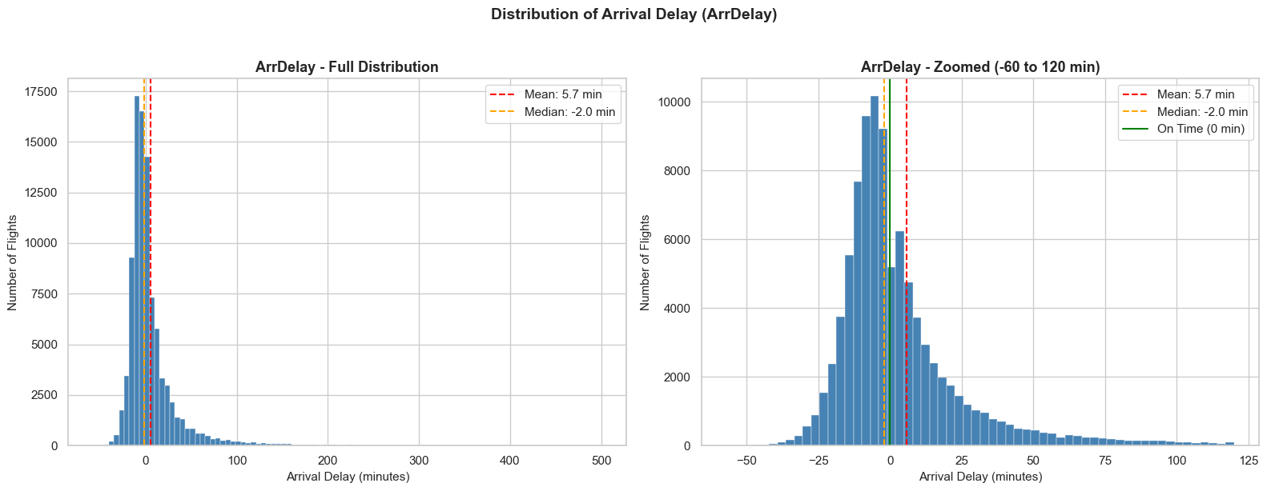
Figure 1: Distribution of Arrival Delay - Full and Zoomed plots
The ArrDelay distribution indicates that most planes arrive on time or early, with a median of 2.0 minutes, despite a mean arrival delay of 5.69 minutes due to long delays. The skews and kurtosis (4.03 and 25.96) highlight the presence of severe outliers, such as delays caused by weather or equipment issues. The regression model must then account for these outliers, as the delays presented range from -57 to 500 minutes.

4.2 Numerical Feature 2: DepDelay (Departure Delay)
This being the strongest predictor for arrival delay in this dataset, 3 methods were used for visual illustration. A histogram to understand distribution, Pearson correlation to quantify the linear relationship with ArrDelay and a scatter plot with a linear regression line.
Statistic | Value
Count | 94,421 flights
Mean | 10.11 minutes
Median (50th) | 1.00 minute
Std Deviation | 27.86 minutes
Min | -44.00 minutes
Max | 516.00 minutes
Skewness | 4.6891
Pearson Correlation (r) | 0.9298
R-Squared (r²) | 0.8646
Regression Line | ArrDelay = 1.0332 x DepDelay + (-4.7945)


Figure 2: Distribution of Departure Delay
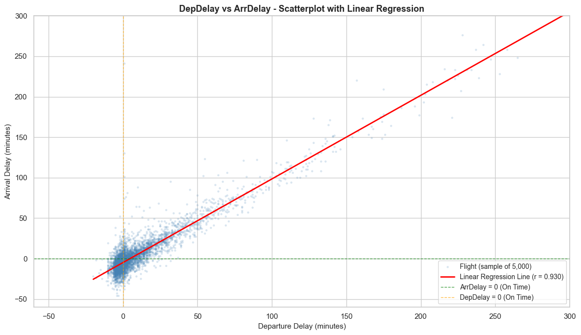
Figure 3: DepDelay vs ArrDelay scatterplot with regression line
During initial data exploration, the Pearson correlation between DepDelay and ArrDelay was 0.942 in the raw dataset of 101,000 rows. After cleaning, the correlation in the final dataset of 94,421 rows dropped to 0.9298, which is a more reliable measure as the cleaning process
Eliminated extreme records that could skew results.
DepDelay exhibits a strong right skewness, indicating that most flights either depart on time or slightly early, with a notable range of severely delayed departures. It has strong positive correlation with ArrDelay, explaining the variance (R²). The scatterplot reveals that flights that depart on time generally arrive on time.

4.3 Categorical Feature 1: UniqueCarrier (Airline Carrier)
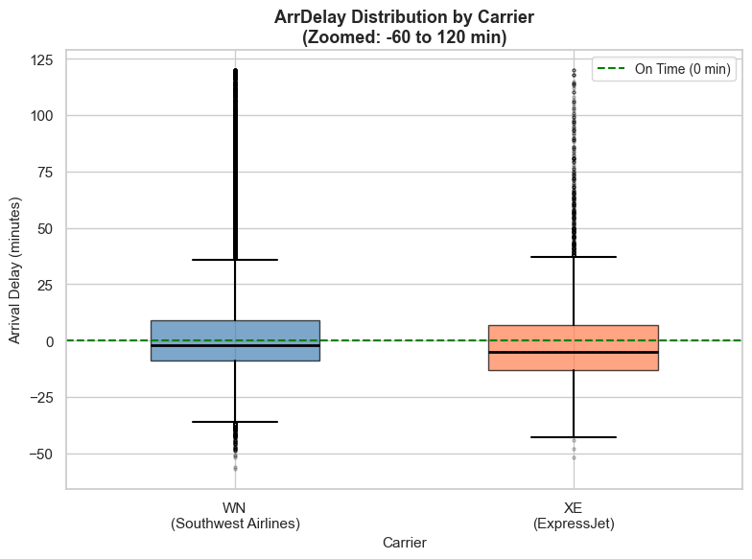
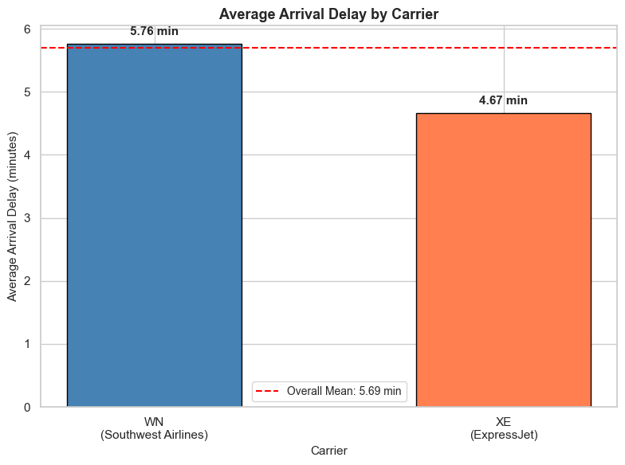
The dataset had two major airline carriers, WN (Southwest Airlines) or XE(ExpressJet), so a bar plot was used to compare average ArrDelay between the two and box plot to show full distribution which included outliers to get a richer picture.
Carrier | Flight Count | Proportion | Mean Delay | Median Delay | Std Dev
WN (Southwest Airlines) | 88,827 | 94.08% | 5.76 min | -2.0 min | 30.38
XE (ExpressJet) | 5,594 | 5.92% | 4.67 min | -4.0 min | 37.89

Figure 4: Average Arrival Delay by Carrier and Box plot ArrDelay Distribution by Carrier
Southwest Airlines (WN) runs 94.08% of the flights in the dataset, which has an effect on overall performance statistics, has a mean arrival of 5.76 minutes compared to ExpressJet’s 4.67 minutes. From the box plot we came to know that both have similar median delays which means early arrivals, but ExpressJEt has a higher standard Deviation, which means that delays are more likely to vary.

4.4 Categorical Feature 2: DayOfWeek
This feature captures the day of the week on which a flight operates (1 = Monday through 7 = Sunday). Business travel peaks on certain days, leisure travel on others. Two bar plot were used, one used to compare average ArrDelay across all seven days and the other to show flight counts per day.
Day | Flight Count | Mean Delay | Median Delay | Std Dev
Monday (1) | 13,734 | 4.51 min | -3.0 min | 29.11
Tuesday (2) | 13,869 | 0.45 min | -4.0 min | 21.68
Wednesday (3) | 13,902 | -1.62 min | -5.0 min | 18.55
Thursday (4) | 16,050 | 13.36 min | 2.0 min | 38.42
Friday (5) | 13,678 | 7.70 min | 0.0 min | 28.17
Saturday (6) | 10,696 | 1.99 min | -4.0 min | 27.30
Sunday (7) | 12,492 | 12.07 min | -0.5 min | 41.77
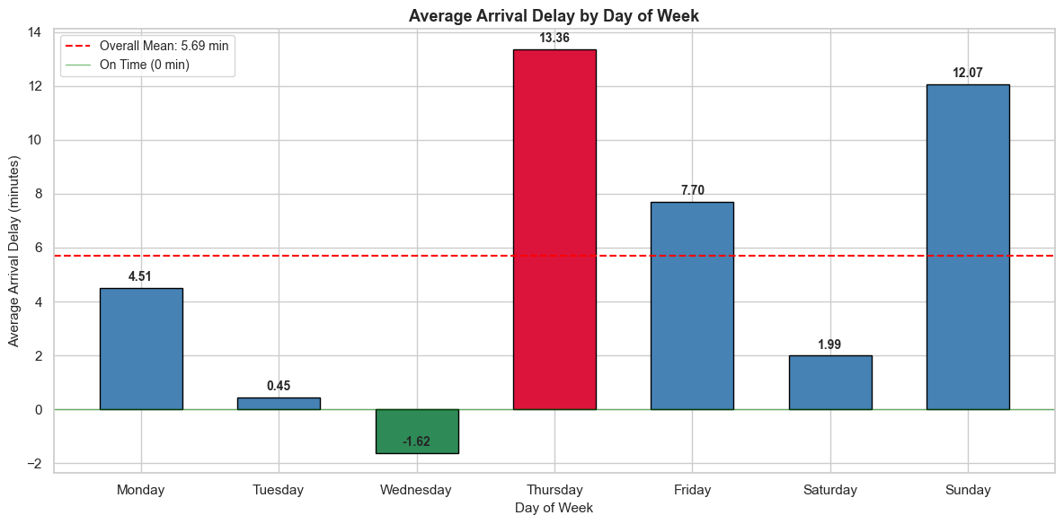
Figure 5: Average Arrival Delay by Day of Week
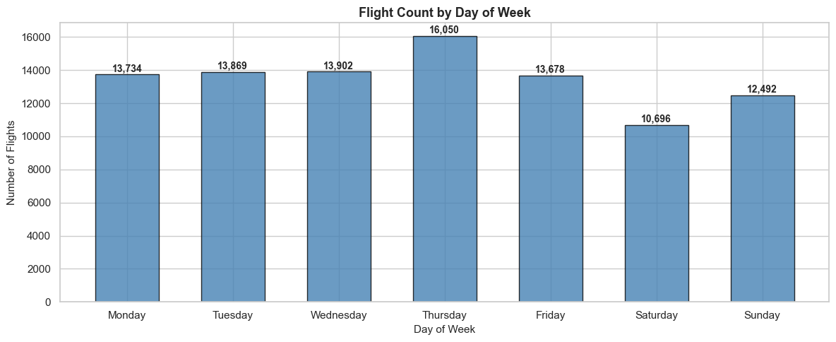
Figure 6: Flight count by Day of Week
Thursday has the worst arrival delays, with an average of 13.36 minutes, while Wednesday has the best, with an average of -1.62 minutes. This shows that the day of week has a big effect on delays. With 16,050 flights, Thursday is the busiest travel day, which causes traffic jams and delays that spread. Sunday has the second longest average delay, 12.07 minutes, because people who are on vacation are coming back. Tuesdays and Wednesdays are days with fewest delays because there is less air traffic. The differences seen between days gives us useful information for future regression models.

4.6 Summary of EDA Findings
Feature | Key Finding | Implication for Modelling
ArrDelay | Strongly right-skewed (skewness = 4.03), median = -2 min, max = 500 min | Target variable has extreme outliers; model must be robust to skewness
DepDelay | Pearson r = 0.9298, R² = 0.8646, slope = 1.03 min per min | Strongest single predictor, most influential feature in future model
UniqueCarrier | WN averages 5.76 min vs XE at 4.67 min. XE has higher variability (Std Dev 37.89 vs 30.38) | Carrier identity adds signal beyond delay magnitude which captures operational variability
DayOfWeek | Thursday worst (13.36 min), Wednesday best (-1.62 min) with a 14.98 min gap | Strong day-level signal, DayOfWeek and IsWeekend should both be included

AI ACKNOWLEDGMENT

I used Claude (Anthropic) from 28th March till 2nd April 2026 to assist with structuring the report layout and understanding how to phrase data insights along with understanding a few python syntaxes like the use of display function etc. Aside from this all code; data analysis, visualizations, cleaning decisions, and final written content are my own. I reviewed, paraphrased, and validated all AI-suggested content before inclusion in this report.

Tool used: Claude (Anthropic)

Dates used: 28th March – 2nd April 2026

How it was used: Assisted with report structure and rephrasing of insights and for a few syntaxes understanding.
My own contribution: All analysis, data cleaning, code, visualizations, and final conclusions are my own.

